双流某重点小学二年级上学期英语期末试题
听力部分（30分）
一、听录音，根据所听内容按A-E给下列图片排序。（10分）
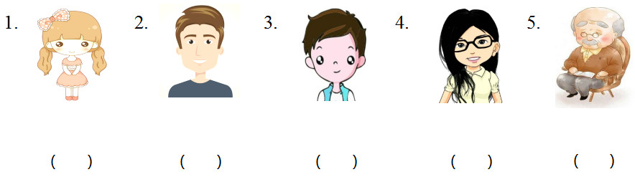
二、听录音，补全短文。（10分）
I have two new 1. ________. The boy is 2. ________. The girl is 3. ________ and 4. ________. They’re my 5. ________ and I like them.
三、听录音，根据对话内容按A-E给下列句子排序。（10分）
（ ）1. His name is Wu Peng.
（ ）2. What does he look like?
（ ）3. Look! That’s my new friend.
（ ）4. He is tall and strong.
（ ）5. What’s his name?

笔试部分（70分）
四、根据汉语意思，补全单词。（10分）
（ ）1. bro _ _ er 兄；弟 A. te B. ht C. th
（ ）2. w _ _ an 女人 A. ou B. om C. ow
（ ）3. sh _ _ t 矮的 A. or B. ur C. ar
（ ）4. g _ _ l 女孩 A. ri B. or C. ir
（ ）5. b _ g 大的 A. a B. o C. i
五、将下列图片与对应的单词连线。（15分）
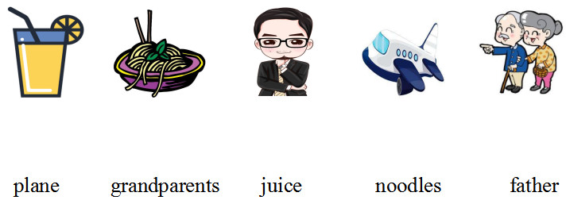
六、单项选择。（10分）
（ ）1. I have egg and apple.
A. a, an B. an, a C. an, an
（ ）2. – does she look like?
–She is tall and thin.
A. What B. Who C. when
（ ）3. Show me schoolbag.
A. his B. Sam C. you
（ ）4. –Goodbye, Andy.
–
A. Me, too. B. Bye. C. Good night.
（ ）5. What that?
A. are B. is C. am
七、找出与其他单词不同类的选项。（10分）
（ ）1. A. tall B. woman C. short
（ ）2. A. water B. milk C. behind
（ ）3. A. he B. who C. she
（ ）4. A. me B. his C. her
（ ）5. A. girl B. does C. boy
八、英汉面对面。（10分）
（ ）1. classmate A. 瘦的
（ ）2. new B. 母亲
（ ）3. thin C. 同班同学
（ ）4. name D. 新的
（ ）5. mother E. 名字
九、从B栏中选出与A栏相应的答语。（15分）
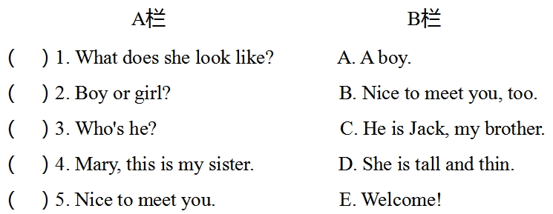

参考答案
听力材料
一、听录音，根据所听内容按A-E给下列图片排序。每小题读一遍。
1. woman 2. grandfather 3. man 4. sister 5. boy
二、听录音，补全短文。短文读两遍。
I have two new classmates. The boy is handsome. The girl is pretty and thin. They’re my friends and I like them.
三、听录音，根据对话内容按A-E给下列句子排序。对话读两遍。
－Look! That’s my new friend.
－What’s his name?
－His name is Wu Peng.
－What does he look like?
－He is tall and strong.
一、1-5 DCEAB
二、1. classmates 2. handsome 3. pretty 4. thin 5. friends
三、1-5 CDAEB
四、1-5 CBACC
五、
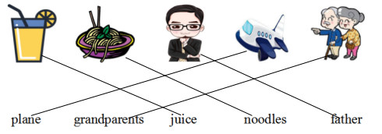
六、1-5 CAABB
七、1-5 BCBAB
八、1-5 CDAEB
九、1-5 DACEB

- END -

